**🏭 Supply Chain Management System**

**A relational database project designed to streamline the management of suppliers, products, warehouses, orders, inventory, and shipments. Built using MySQL, this system simulates the real-world operations of a supply chain in a structured, query-driven environment.**

**📚 Features**

* **Manage Suppliers with contact details**
* **Track Products, unit prices, and associated suppliers**
* **Maintain Inventory across multiple Warehouses**
* **Monitor and query Shipments with status and delivery info**
* **Handle Orders per warehouse with product-level details**
* **Includes 20+ SQL queries for analysis, optimization, and reporting**

**🛠️ Technologies Used**

* **Database: MySQL**
* **File: project_supply_chain_management_system.sql**

**🗃️ Database Schema Overview**

* **Suppliers (SupplierID, Supplier Name, ContactName, Phone, Email, Address)**
* **Warehouses (WarehouseID, WarehouseName, Location)**
* **Products (ProductID, ProductName, Description, UnitPrice, SupplierID)**
* **Inventory (InventoryID, ProductID, WarehouseID, Quantity)**
* **Shipments (ShipmentID, SupplierID, WarehouseID, ShipmentDate, ArrivalDate, Status)**
* **Orders (OrderID, ProductID, WarehouseID, Quantity, OrderDate, Status)**

**Database Diagram**

**📦 How to Use**

1. **Import the database:**
   * **Open your MySQL client (e.g., phpMyAdmin or MySQL Workbench)**
   * **Create the database:**

**CREATE DATABASE Supply_Chain_Management_System;**

* + **Import the file: project_supply_chain_management_system.sql**

1. **Explore the schema:**
   * **Use SHOW TABLES; to see available tables**
   * **Run included queries to analyze inventory, orders, and more**

**SQL Table Query screenshot**

**A relational database project designed to streamline the management of suppliers, products, warehouses, orders, inventory, and shipments. Built using MySQL, this system simulates the real-world operations of a supply chain in a structured, query-driven environment.**

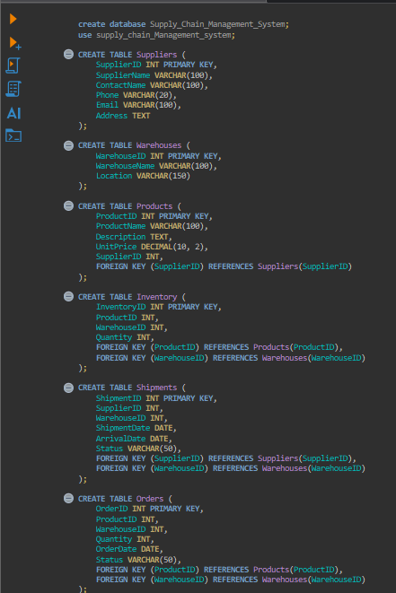

**Input Values**

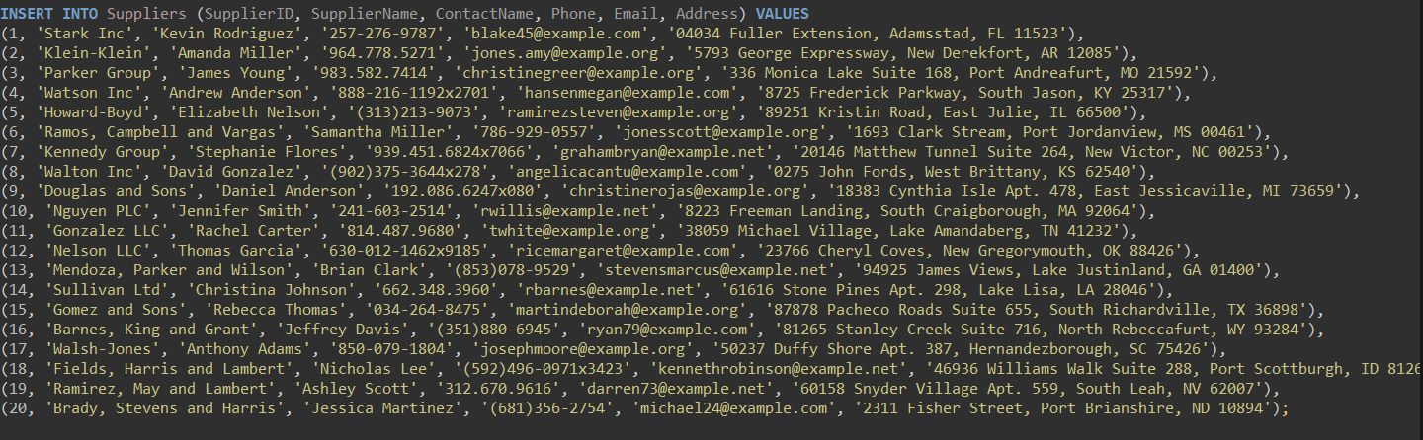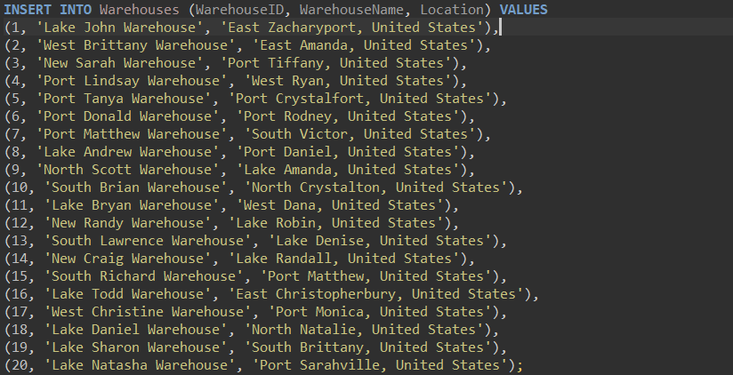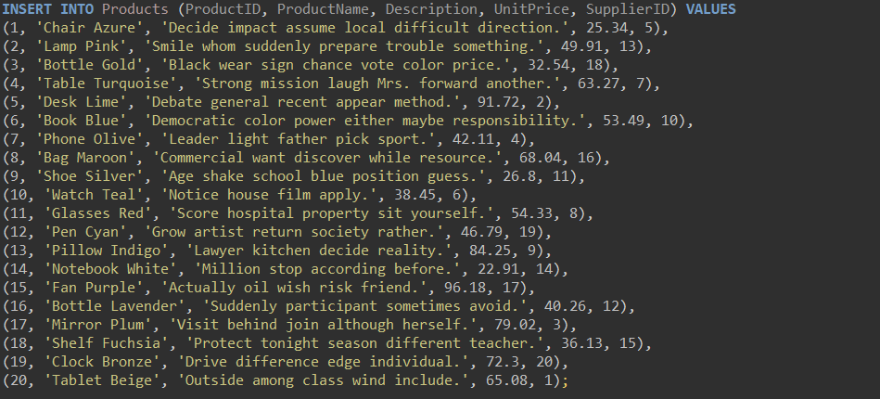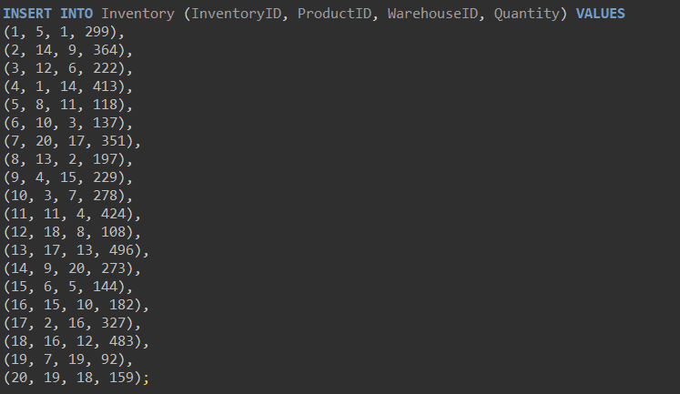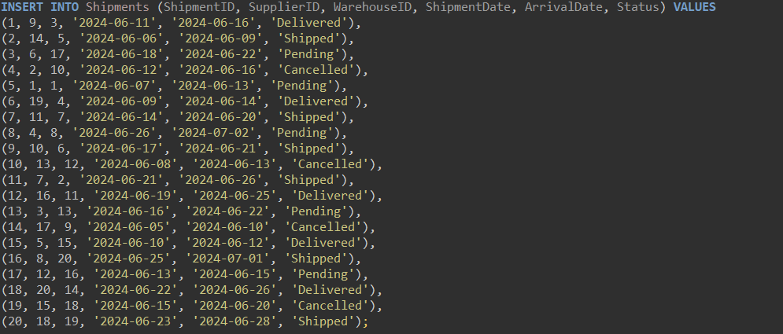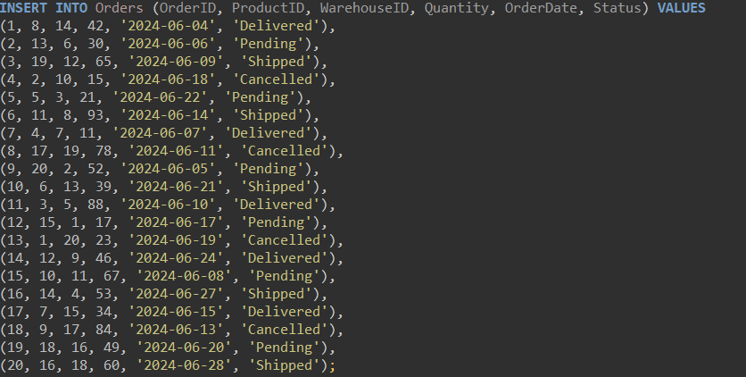

**🧠 Sample Analytical Queries**

* **Top 5 most ordered products**
* **Inventory value per product (price × quantity)**
* **Delayed shipments beyond expected delivery**
* **Cancelled or pending orders**
* **Warehouses with the most shipment activity**
* **Products that were never ordered**

**These are pre-written and available at the end of the .sql file under comments.**

**Sql query and Output**

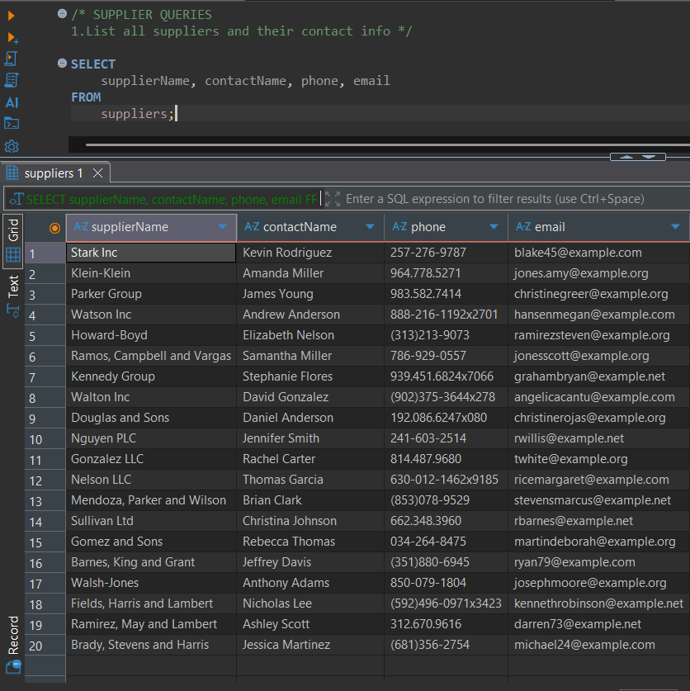

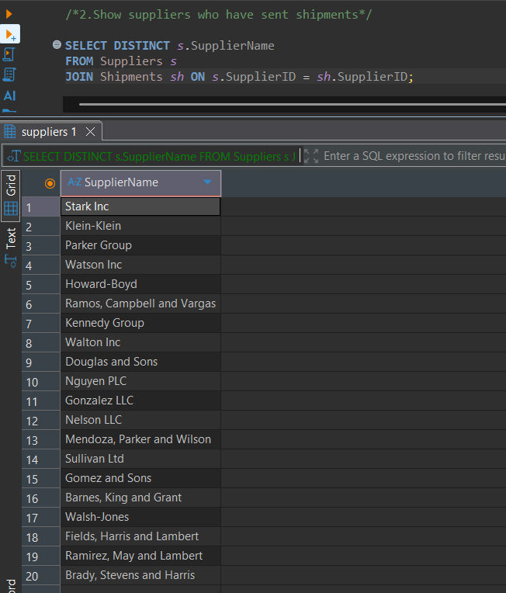

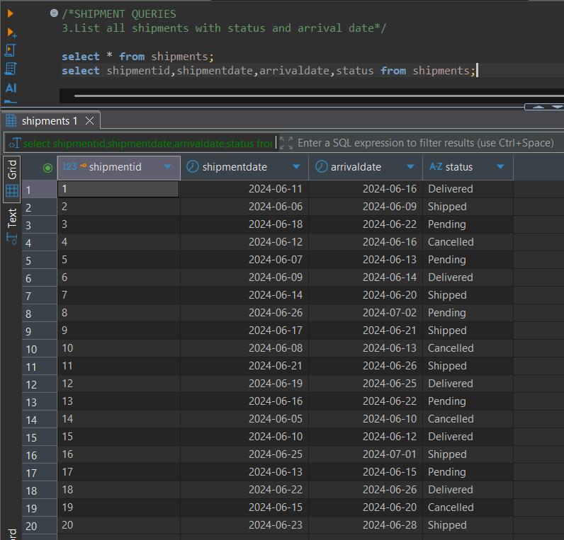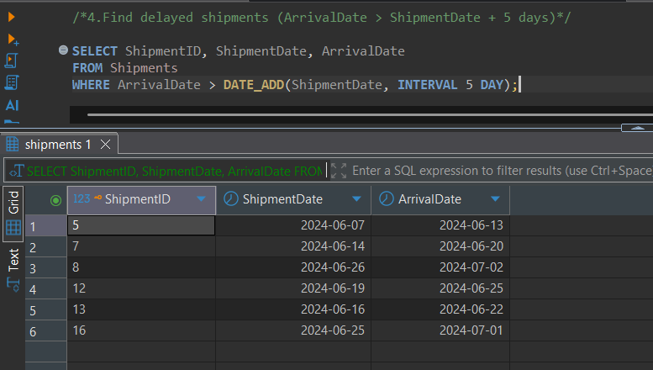

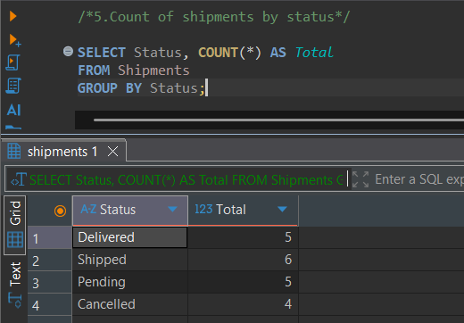

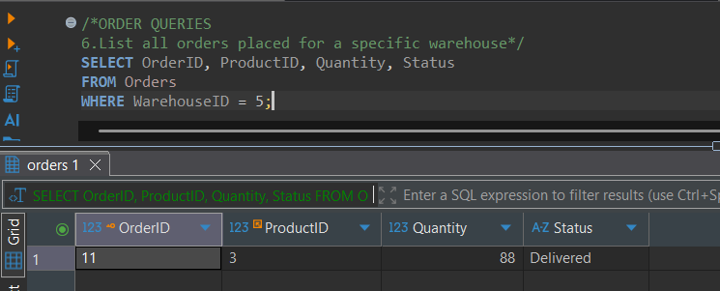

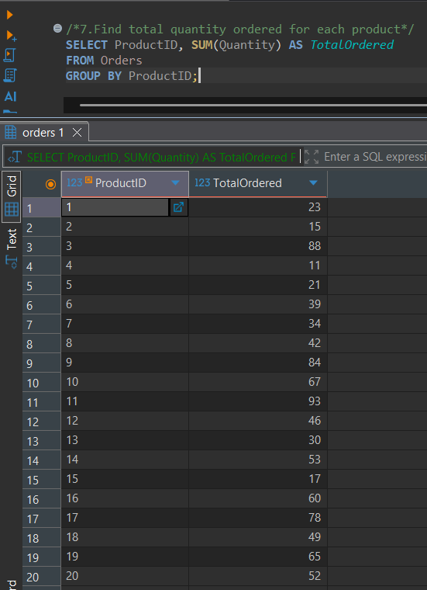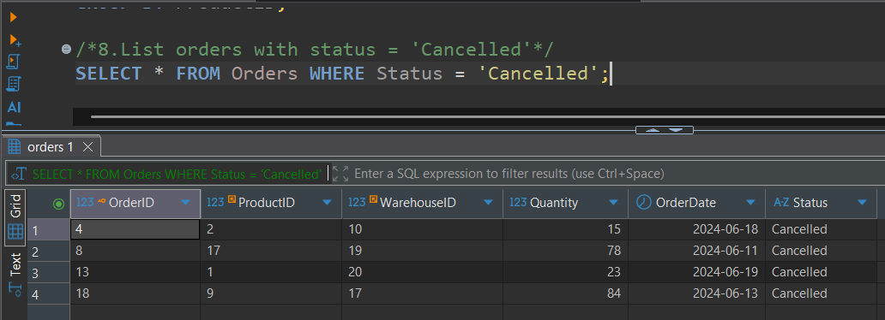

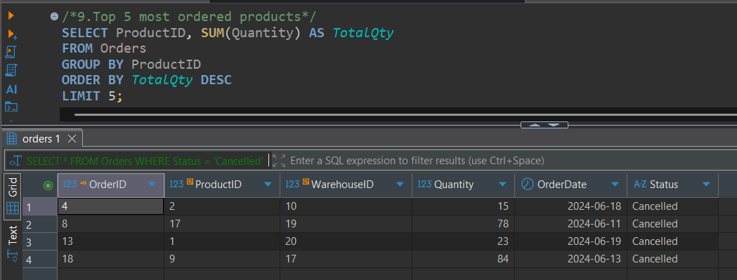

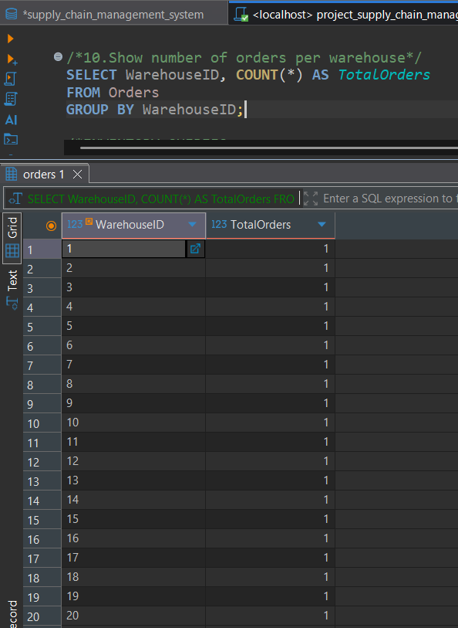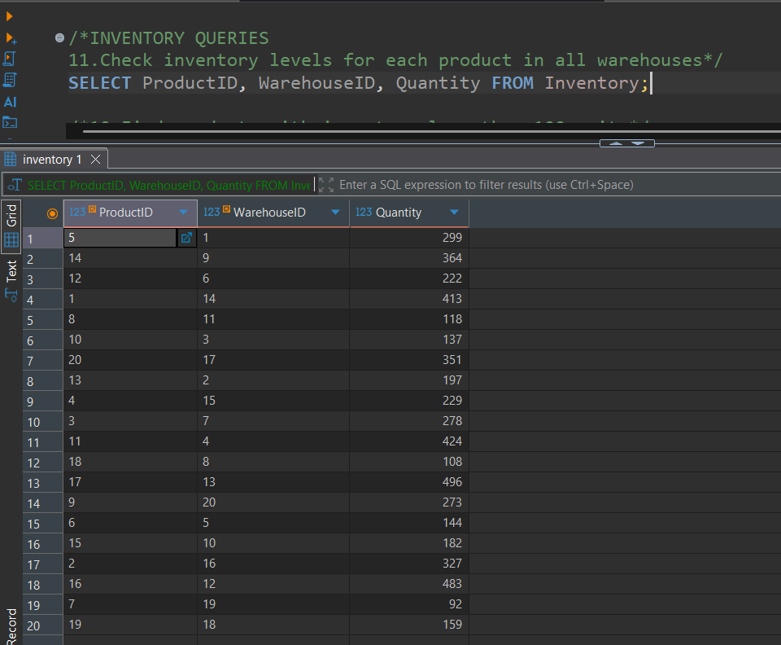

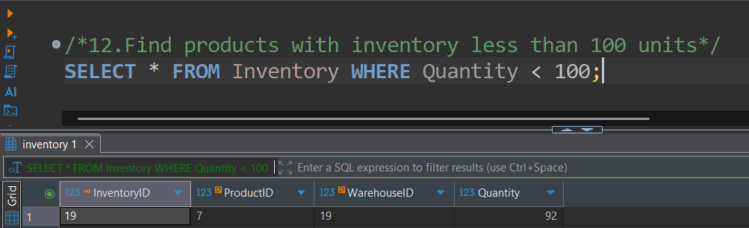

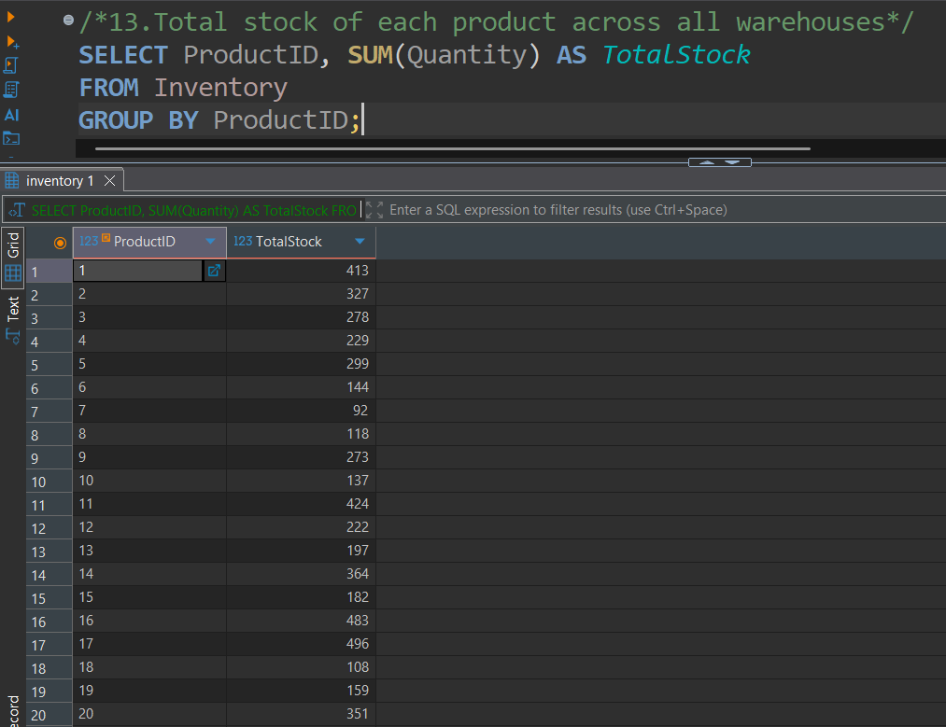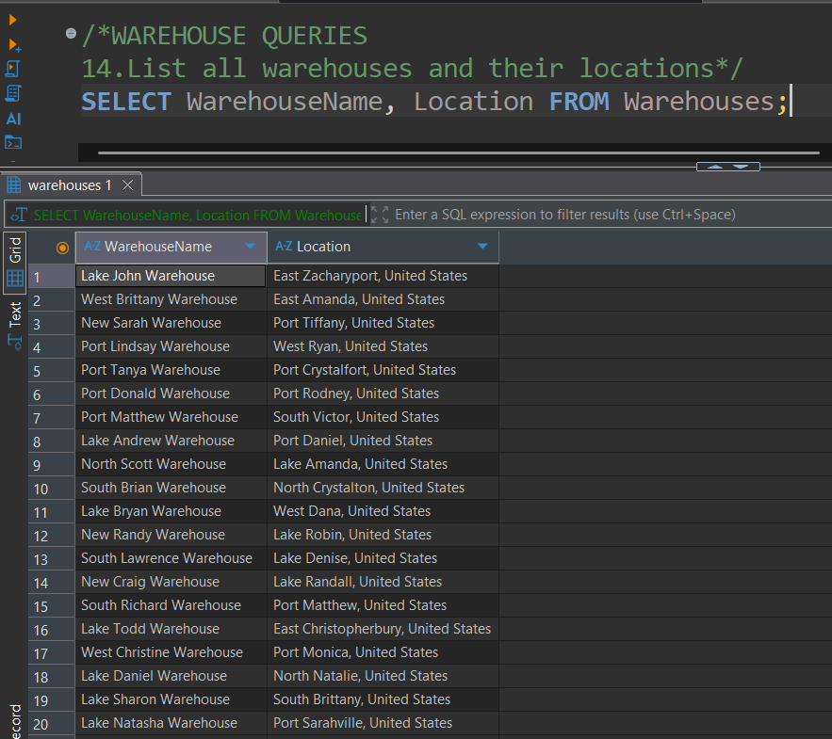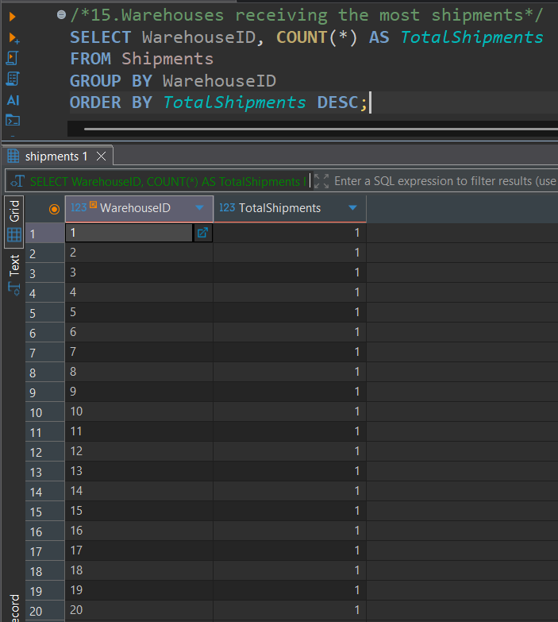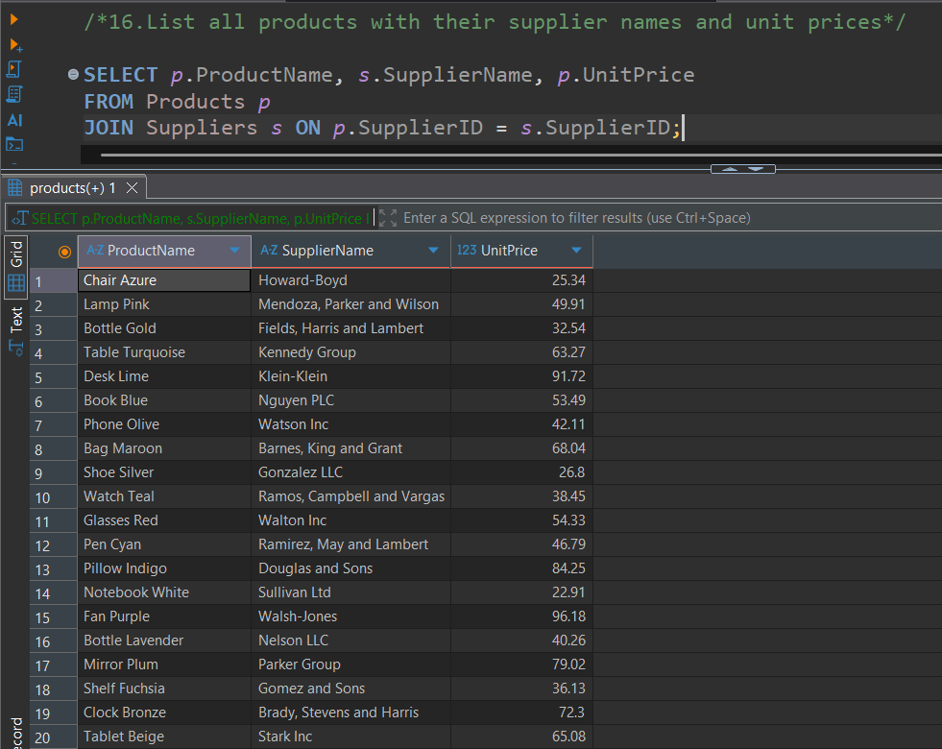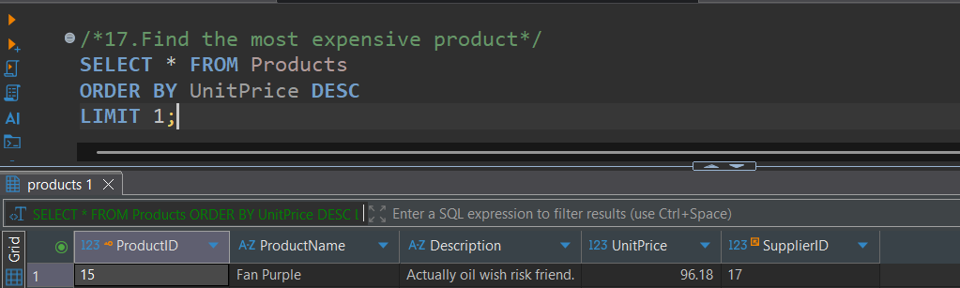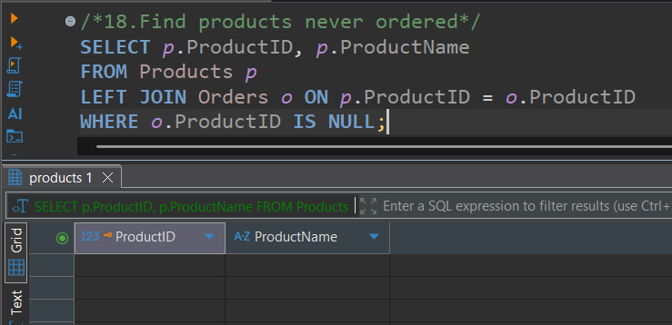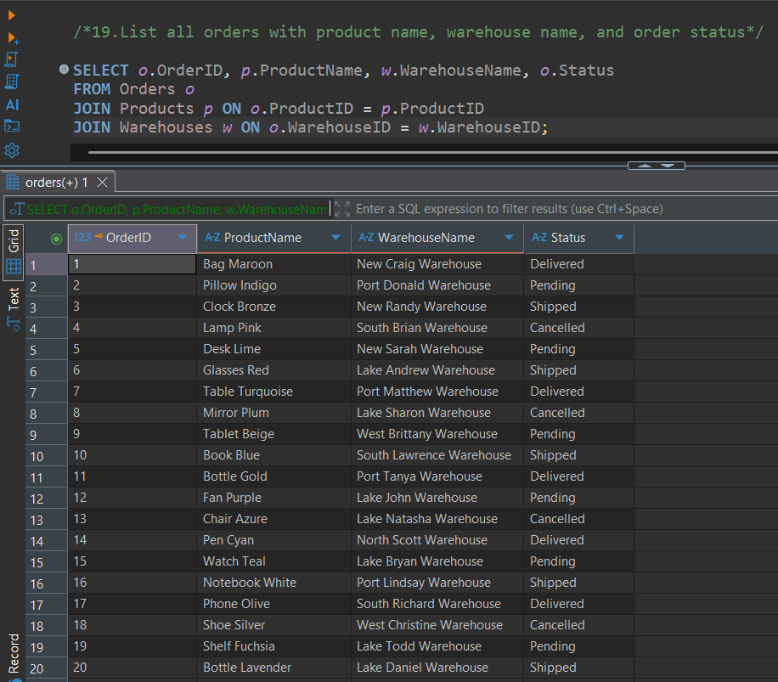

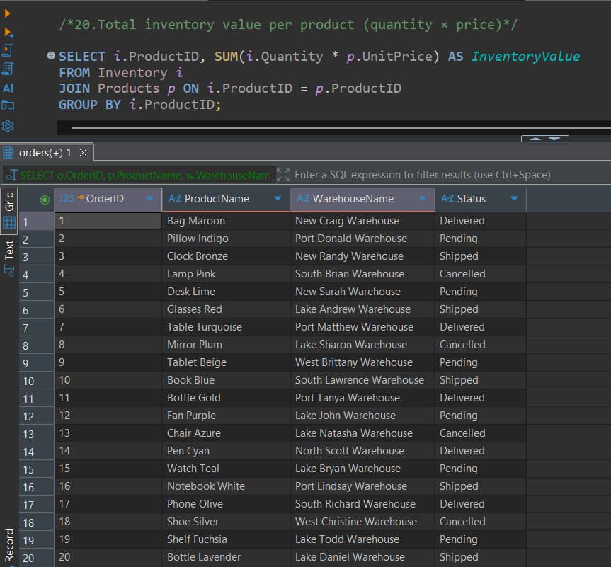

**📝 License**

**This project is open-source and intended for academic, training, and demonstration purposes. Contributions are welcome!**

**🐙 GitHub:**[**github.com/IAMDHARMA**](https://github.com/IAMDHARMA/Supply_Chain_Management_System.git) **👤 Author**

**Dharmarajan M** [**LinkedIn Profile**](https://www.linkedin.com/in/dharmarajan-ai)